CASE FILE 12
Bounce Zone Trampoline Park
Product line: visit passes
Bounce Zone is a trampoline park in an old warehouse in Wheeling. The same $20 pass is sold to toddlers, teenagers, and adult athletes, and nobody is completely happy.
Your job: Build a lineup of three versions, one for each segment below. For every version, choose its features and set its price. Your goal is the most total profit across all three.
THE MARKET: THREE SEGMENTS
Bounce Zone Trampoline Park surveyed people in the Chicago area. The survey split them into three groups. Read the profiles, then give each segment a name.
SEGMENT A  14,000 potential customers | SEGMENT B  6,000 potential customers | SEGMENT C  3,000 potential customers
- Ages 13 to 18, comes with a group of friends  - Visits on Friday and Saturday nights  - Wants music, lights, and a place to hang out  “We need somewhere to go that isn't the mall.” | - Parents of kids ages 2 to 5  - Visits weekday mornings  - Worried about big kids landing on little ones  “If it's clean and the big kids aren't there, I'm in.” | - Ages 16 to 35, trains for obstacle races  - Wants a workout, not a party  - Would come 2 or 3 times a week  “I want the obstacle course, not the foam pit.”
Our name for them: | Our name for them: | Our name for them:
PRODUCT BASICS
Base cost of every version | $4 per visit, before any features are added
Price options | $10 $15 $20 $28 $38 $50 (each version must use one of these prices)
WARM-UP: READ THE DATA FIRST
1. Which segment has the most must-have features (60% or higher)? How many does it have?

2. What is the most expensive feature on the menu? Which segment, if any, says it is a must-have?

3. What is the lowest price at which fewer than half of Segment B would buy?

4. If Bounce Zone Trampoline Park sold a version with a Fit of 100% to Segment A at $20, how many people would buy it?

SURVEY RESULTS: WHAT EACH SEGMENT REQUIRES
Question asked: “Which of these would a visit pass need to have before you would buy it?”
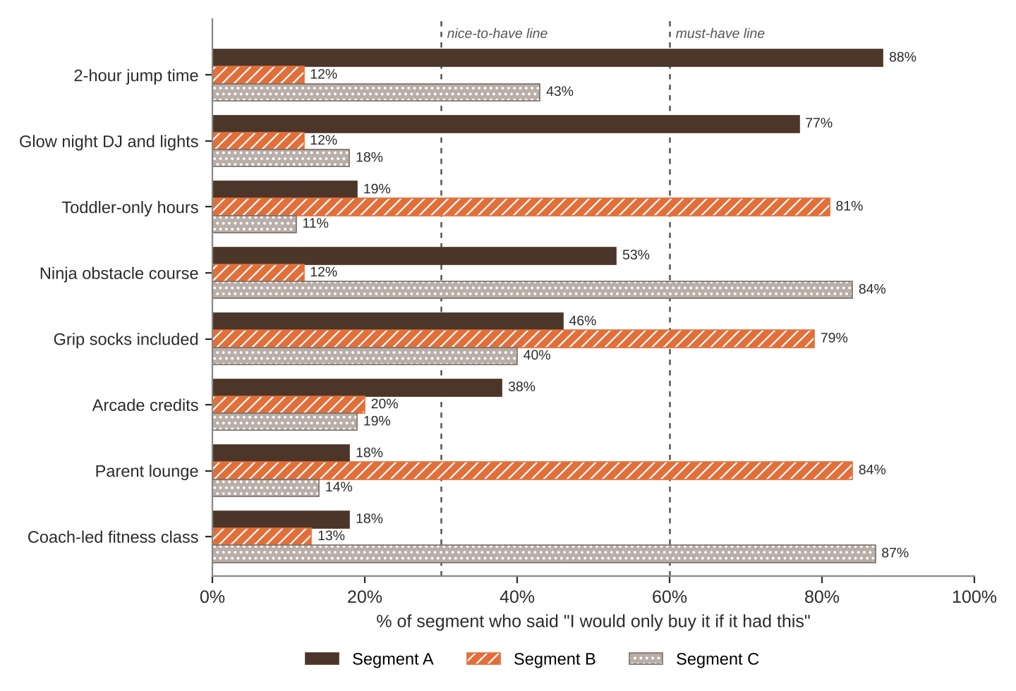
FEATURE MENU
Every feature you add raises your cost per visit. Add a feature to any version you want.
Feature | What it is | Cost to add
2-hour jump time | Two hours instead of one | $3
Glow night DJ and lights | Music and blacklights on weekend nights | $2
Toddler-only hours | Weekday mornings for ages 5 and under | $3
Ninja obstacle course | Warped wall and ninja course access | $4
Grip socks included | Required socks at no extra charge | $1
Arcade credits | $5 in arcade play | $2.50
Parent lounge | Coffee, WiFi, and seats with a view | $2
Coach-led fitness class | 45-minute class with a trainer | $6
SURVEY RESULTS: WHAT EACH SEGMENT WILL PAY
Question asked: “If it had everything you need, would you buy it at this price?”
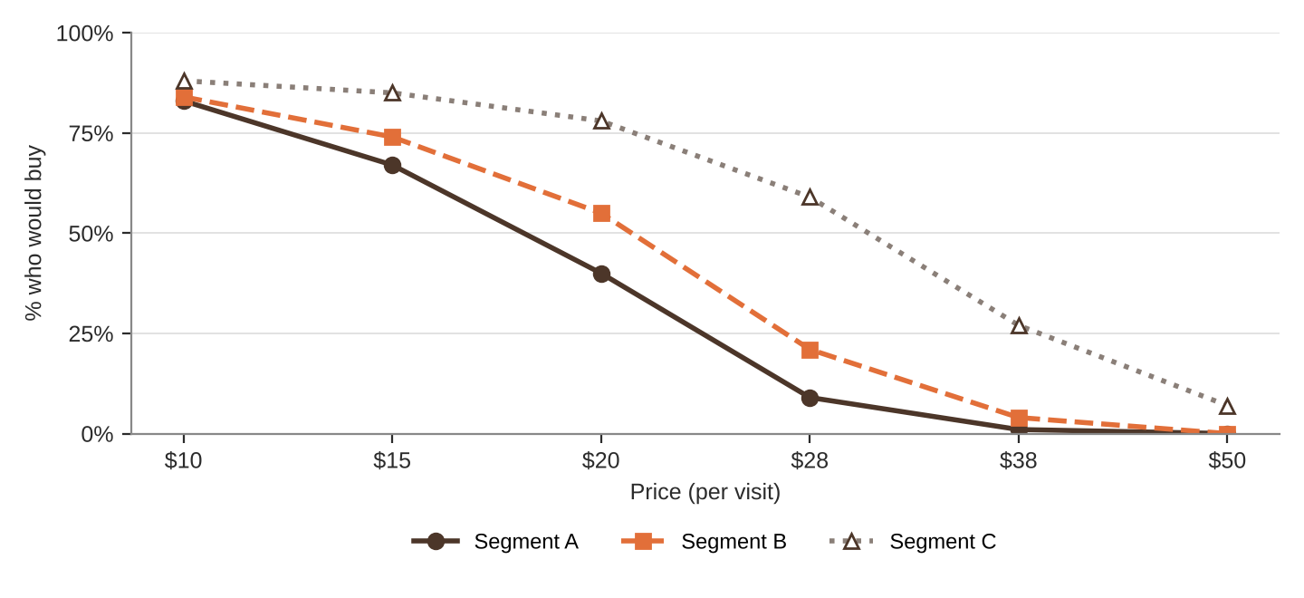
% of each segment who would buy at each price
Price | $10 | $15 | $20 | $28 | $38 | $50
Segment A | 83% | 67% | 40% | 9% | 1% | 0%
Segment B | 84% | 74% | 55% | 21% | 4% | 0%
Segment C | 88% | 85% | 78% | 59% | 27% | 7%
QUICK RULES
Must-have | A feature that 60% or more of a segment requires. Leave one out and that segment's buyers are cut in half. Leave two out and they're cut in half again.
Nice-to-have | A feature that 30% to 59% of a segment requires. Each one you include adds 5% to Fit.
Under 30% | That segment doesn't care. It adds cost and nothing else.
Fit | Start at 100%. Add 5% for each nice-to-have included. Then cut in half for each must-have left out.
Buyers | Segment size × % who would buy at your price × Fit. Round to a whole number.
Profit | Buyers × (Price − Unit cost). Unit cost = base cost + cost of every feature you added.

